**Project Report**

On

**Automatic Accident Detection and Rescue Management System**

*****Submitted*

*In partial fulfilment*

*For the award of Degree of*

**PG Diploma in Embedded Systems and Design**

**(PG-DESD)**

**(C-DAC, ACTS (Pune))**

**Guided By: Submitted By:**

**Mr. Bhupendra Pratap Singh Abhishek Fartade (230340130001)**

**Ankita Singh (230340130009)**

**Gaikwad Atul Jalindar (230340130019)**

**Jadhav Abhishek Devidas (230340130020)**

**Riya Soni (230340130043)**

**Centre for Development of Advanced Computing (C-DAC), ACTS (Pune- 411008)**

**Acknowledgement**

This is to acknowledge our indebtedness to our Project Guide, **Mr. Bhupendra Pratap Singh** C-DAC ACTS, Pune for his constant guidance and helpful suggestion for preparing this project **Automatic Accident Detection and Rescue Management System**.

We express our deep gratitude towards him for his inspiration, personal involvement, constructive criticism that she provided us along with technical guidance during the course of this project.

We take this opportunity to thank Program head **Ms. X** and Head of the department **Mr. X** for providing us such a great infrastructure and environment for our overall development.

We express sincere thanks to **Ms. X**, Process Owner, for their kind cooperation and extendible support towards the completion of our project.

It is our great pleasure in expressing sincere and deep gratitude towards **Ms. X** (Course Coordinator, PG-DESD) for their valuable guidance and constant support throughout this work and help to pursue additional studies.

Also our warm thanks to C-DAC ACTS Pune, which provided us this opportunity to carryout, this prestigious Project and enhance our learning in various technical fields.

**Abhishek Fartade (230340130001)**

**Ankita Singh (230340130009)**

**Gaikwad Atul Jalindar (230340130019)**

**Jadhav Abhishek Devidas (230340130020)**

**Riya Soni (230340130043)**

## **Abstract**

Speed is one of the basic reasons for vehicle accident. Many lives could have been saved if emergency services could get accident information and reach in time. This project deals with accident detection system when the accident occurs it uses various components and alerts the Rescue team for help. An efficient automatic accident detection with an automatic notification to the emergency service with the accident location is a prime need to save the precious human life. The proposed system deals with accident alerting and detection. It reads the exact latitude and longitude of the vehicle involved in the accident and sends this information to nearest emergency service provider. The goal of the project is to detect accidents and alert the rescue team in time

## **Table of Contents**

|  |  |  |
| --- | --- | --- |
| **S. No** | **Title** | **Page No.** |
|  | **Front Page Acknowledgement Abstract**  **Table of Contents** | **I**  **II**  **III** |
| **1**  **1.1**  **1.2** | **Introduction**  Introduction  Objective and Specifications | **1-2**  **1**  **2** |
| **2** | **Literature Review** | **3-4** |
| **3** | **Methodology/ Techniques** | **5-10** |
| **3.1** | Approach and Methodology/ Techniques | **5** |
| **3.2** | Component Used | **6-10** |
| **4** | **Implementation** | **11-12** |
| **4.1** | Implementation | **11** |
| **4.2**  **4.3** | Hardware Configuration  Software Required | **11**  12 |
| **5** | **Results** |  |
| **5.1** | Results | **13** |
| **6** | **Conclusion** |  |
| **6.1** | Conclusion | **14** |
| **7** | **References** |  |
| **7.1** | References | **15** |

**Chapter-1**

## **Introduction**

**1.1 Introduction**

The constant improvement of technology, population and economy is leading to expansion of human civilization in search of better prospects. As expected an implosion of transportation system is observed and managed everyday. These increment in number of vehicles on road, air or sea result in increased chance of vehicular accidents [1][2].

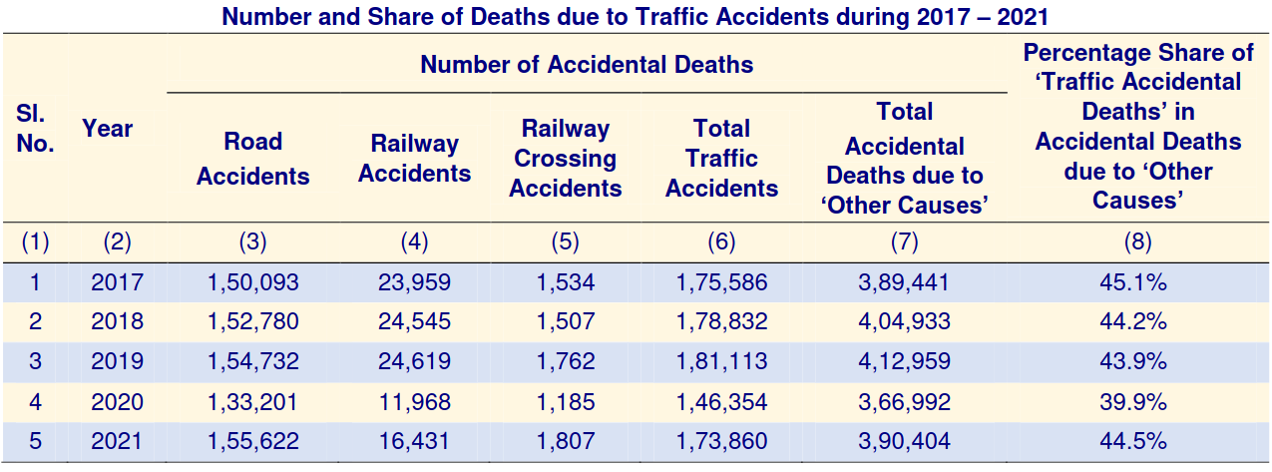Figure 1 Rise of accidents according to National Crime Records Bureau of India

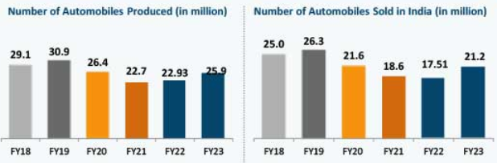Figure 2 Rise in vehicles in India according to India Brand Equity Foundation

The accidents must be reported immediately in order to provide quick and proper medical assistance. There is also rise in unreported accidents and undocumented amount of property damage [3].

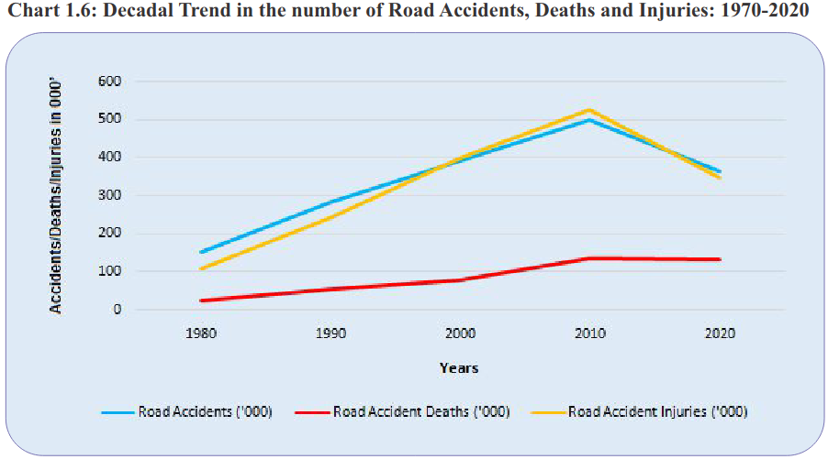Figure 3 Rise in vehicular accident related deaths according to Ministry of Road Transport and Highways

**1.2 Objective and specification**

**Objective:**

The objective of our project are:

1. Detect accident as quickly as possible.

2. Have minimum false detection.

3. Immediately message current location and call for help.

**Specification:**

Components: 1x ESP32-WROOM-32

1x MPU-6050

1x SIM900A

1x HCSR-04

1x BH1750

1x Buzzer

1x Display

1x Piezoelectric crystal

OS: FreeRTOS

Protocol: MQTT

UART

**Chapter-2**

**Literature Review**

**2.1 Research and technical papers**

**2.1.1 ACCIDENT DETECTION AND REPORTING SYSTEM USING GPS, GPRS AND GSM TECHNOLOGY (@2012 IEEE):**

This paper proposes to utilize the capability of a GPS receiver to monitor the speed of a vehicle and detect an accident basing on the monitored speed and send the location and time of the accident from GPS data processed by a micro-Controller by using the GSM network to the Alert Service Centre. At high speeds the distance between starting to brake and a complete stand still is longer. The braking distance is proportional to the square of speed. Therefore, the possibility to avoid a collision becomes smaller. There is a tabular column for predicting the maximum speed after considering the deceleration factors. As such, if the speed is less than these maximum speeds, than it would be assumed that some other deceleration force worked on the vehicle to reduce the speed and an accident has occurred. Speedometer can also be used to find the speed drops in vehicles, but an analogue to digital converter is required to acquire speed from it. So, a GPS is used to track the speed of vehicle every instance. The vehicle speed is calculated at every instance by GPS. If there is decrease in new speed values then it raises an ALARM for accident detection. Then 5 secs will be given to abort the emergency Else the emergency is sent to Alert Service Centre and plot the location of accident by the GSM number received. There after rescuing the individual.

**2.1.2 REAL TIME DETECTION AND REPORTING OF VEHICLE COLLISION (@2017 IEEE):**

This paper proposes to utilize the capability of Accelerometer and Gyroscope to obtain the data and detect an accident basing on the orientation angle and orientation. Then send the location of the accident from GPS data processed by a micro controller by using the GSM network to the nearest hospital provided over the network and alerts their family members too. The accelerometer detects the direction of vehicle collision by bi-directional axis and an axis towards gravitational force with full scale +/-8g. The collision of a vehicle leads to a drastic change in vehicle speed and shows a direct impact on acceleration force along that axis of crash. As the Z-axis is oriented along the gravitational force direction, only X-axis and Y-axis of accelerometer is required to determine the happening and direction of vehicle collision. The gyroscope is used to calculate the tilt of collision vehicle and is given a full range of +/-500 degree/sec. Angle greater above 46 degree and below -46-degree results in rollover of car. Other than the threshold f roll and pitch values, the weight and center of gravity of vehicle plays an important role in rollover. Once the threshold is reached, the notification system will be activated informing the family and nearby hospital about the occurrence of vehicle rollover. In addition, they use GPS tracker too for recording false assumptions from the GPS data acquired. The notification system notifies the information to family emergency contacts and nearest hospital. Notification system is activated once the threshold for detection is reached. Location is identified by GPS.

**2.1.3 VEHICLE ACCIDENT DETECTION SYSTEM BY USING GSM, GPS AND SENSORS (@2019, IRJET):**

This paper proposes to utilize the capability of a Piezoelectric sensor to detect an accident basing on the voltage produced by collision and send the location and time of the accident from GPS data processed by a micro-Controller by using the GSM network to the Alert Service Centre. The Piezoelectric sensor produces a DC voltage proportional to impacts on collision on vehicle. When the voltage increases above threshold value the sensors get triggered. The Latitude and Longitude are detected using GPS and it is sent as message to rescue team through GSM module. The message is received by another GSM module. Google Map Module: It displays Google map shows you exact location of accident and its details. It gets detail SMS from accident location. Hence there is small variation in co-ordinates .An OFF switch is also provided at times of need to avoid false message.

**Chapter -3**

**Methodology/Techniques**

This Chapter describes about the requirements. It specifies the hardware and software requirements that are in order to run the system properly. The Hardware Requirement Specification is explained in detail, which includes the overview of functional and non-functional requirements.

**3.1 Approach and Methodology**

The designed system detects accidents instantly and informs the emergency services or concerned person. ESP 32 microcontroller act as a heart to the proposed system. It is a low-power on-chip microcontroller which has in built Wi-Fi , it is also battery friendly. There are several sensors interfaced to the ESP 32 to detect the accident when it occurs.

Accelerometer

MPU-6050

Esp-32

The ESP32 microcontroller is the main processing unit of the system. It collects data from the various sensors, including MPU6050, GPS, Light and ultrasonic sensors. The MPU6050 sensor is used to detect sudden changes in the vehicle's acceleration and orientation. The light sensor is used to detect the visibility. Along with these sensors the GPS and GSM modules are incorporated to detect the vehicle location and for sending the notifications to the related people and emergency services respectively. When an accident is detected, the system triggers an alert mechanism that can send an SMS or phone call to the vehicle owner or emergency services. The alert message includes the location of the accident. The system can also be configured to automatically call emergency services or the vehicle owner, providing them with more information about the accident. Rescue services, such as ambulance or police, can respond quickly to the alert and provide necessary assistance.

Figure 4 Proposed Work

Ultra-Sonic sensor

HC-SR04

Light –sensor

BH1750

GPS/GSM

Esp-32

MQTT\REST

MQTT

MQTT

IOT Platform

Server

**3.2 Components Used**

* MPU6050
* BH1750
* HC-SR04
* SIM900A
* ESP-32
* NEO-6M

**3.2.1 MPU6050**

The MPU-6050 is a popular sensor module that combines a 3-axis gyroscope and a 3-axis accelerometer in a single package. It is designed to provide accurate motion tracking data for various applications such as robotics, drones, gaming, and virtual reality. The MPU-6050 module is based on the InvenSenseMPU-6050 IC, which features a digital motion processor (DMP) that processes the raw sensor data and outputs the orientation of the sensor in the form of quaternions, Euler angles, or rotation vectors. The MPU-6050 module communicates with a microcontroller or a computer using the I2C interface, and it is compatible with various development platforms such as Arduino, Raspberry Pi, and STM32. The key features of the MPU-6050 module include:

• 6 degrees of freedom (DOF) sensing: 3-axis gyroscope and 3-axis accelerometer.

• Digital motion processing: DMP provides orientation data in various formats.

• Low power consumption: typically consumes 3.9mA in active mode and 5µA in sleep mode.

• Wide operating voltage range: 2.375V to 3.46V

• Compact size: 4x4x0.9mm QFN package Overall, the MPU-6050 is a versatile and cost-effective sensor module that can provide accurate motion tracking data for a wide range of applications.

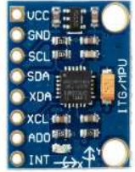

Figure 5 MPU6050

**3.2.2 BH1750**

BH1750 is an digital Ambient Light Sensor IC for I2 C bus interface. This IC is the most suitable to obtain the ambient light data for adjusting LCD and Keypad backlight power of Mobile phone. It is possible to detect wide range at High resolution (1 - 65535 lx ).The key features of BH1750,

* I2 C bus Interface ( f / s Mode Support )
* Spectral responsibility is approximately human eye response.
* Illuminance to Digital Converter.
* Wide range and High resolution. ( 1 - 65535 lx )
* Low Current by power down function.
* 50Hz / 60Hz Light noise reject-function
* 1.8V Logic input interface
* No need any external parts
* Light source dependency is little (ex. Incandescent Lamp. Fluorescent Lamp. Halogen Lamp. White LED. Sun Light )
* It is possible to select 2 type of I2 C slave-address.
* Adjustable measurement result for influence of optical window (It is possible to detect min. 0.11 lx, max. 100000 lx by using this function. )
* Small measurement variation (+/- 20%) 13) .The influence of infrared is very small.

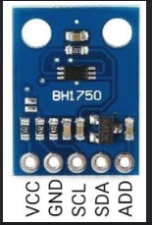

Figure 6 BH1750

**3.2.3 HC-SR04**

HC-SR04 User Guide 1. Ultrasonic Distance Measurement Principles The transmitter emits a 8 bursts of an directional 40KHz ultrasonic wave when triggered and starts a timer. Ultrasonic pulses travel outward until they encounter an object, The object causes the the wave to be reflected back towards the unit. The ultrasonic receiver would detect the reflected wave and stop the stop timer. The velocity of the ultrasonic burst is 340m/sec. in air. Based on the number of counts by the timer, the distance can be calculated between the object and transmitter The TRD Measurement formula is expressed as.The key features of HC-SR04,

* Stable performance (Xtal.)
* Accurate distance measurement
* High-density SMD Board
* Close Range (2cm)

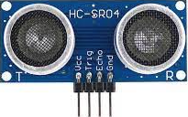

Figure 7 HC-SR04

**3.2.4 SIM900A**

GSM/GPRS Modem-RS232 is built with Dual Band GSM/GPRS engine- SIM900A, works on frequencies 900/ 1800 MHz. The Modem is coming with RS232 interface, which allows you connect PC as well as microcontroller with RS232 Chip(MAX232). The baud rate is configurable from 9600-115200 through AT command. The GSM/GPRS Modem is having internal TCP/IP stack to enable you to connect with internet via GPRS. It is suitable for SMS, Voice as well as DATA transfer application in M2M interface. The onboard Regulated Power supply allows you to connect wide range unregulated power supply . Using this modem, you can make audio calls, SMS, Read SMS, attend the incoming calls and internet through simple AT commands.It includes following features,

* Dual-Band GSM/GPRS 900/ 1800 MHz.
* RS232 interface for direct communication with computer or MCU kit.
* Configurable baud rate.
* Power controlled using 29302WU IC.
* ESD Compliance.
* Enable with MIC and SPeaker socket.
* With slid in SIM card tray.
* With Stub antenna and SMA connector.
* Input Voltage: 12V DC.

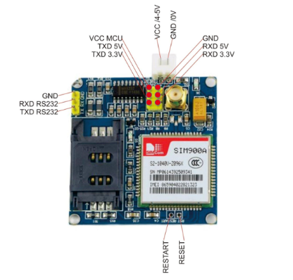

Figure 8 SIM900A

**3.2.5 ESP-32**

ESP32 is a popular microcontroller developed by Espressif Systems, which is designed to provide a low-cost, low-power, and high-performance solution for a variety of Internet of Things (IoT) applications. It is an upgrade from the previous version, ESP8266, and comes with a range of new features and capabilities. One of the key features of ESP32 is its built-in Wi-Fi and Bluetooth connectivity, which allows the device to communicate wirelessly with other devices and the internet. It also supports other wireless protocols, such as Zigbee, Z-Wave, and LoRa, making it suitable for a wide range of IoT applications. ESP32 comes with a range of on-board sensors, including temperature, hall effect, and capacitive touch sensors, which can be used for a variety of applications. It also has an ultra-low power consumption mode, which makes it ideal for battery-powered applications. ESP32 can be programmed using various programming languages, including C, C++, and MicroPython. There are also a number of development tools and Integrated Development Environments (IDEs) available, including the popular Arduino IDE, ESP-IDF, and MicroPython IDE. In summary, ESP32 is a powerful and versatile microcontroller that provides a range of features and capabilities for a variety of IoT applications. With its built-in Wi-Fi and Bluetooth connectivity, low power consumption, and wide range of I/O interfaces, it has become a popular choice for IoT developers and hobbyists around the world.

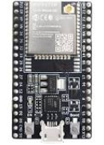

Figure 9 ESP-32

**3.2.6 NEO-6M**

A GPS (Global Positioning System) module is an electronic device that is used to receive and process signals from GPS satellites in order to determine the device's location on the earth's surface. The NEO-6M is a popular GPS module that is commonly used in various projects and applications. It is a small and inexpensive module that can provide accurate positioning data using the GPS satellite system. The NEO-6M GPS module consists of a GPS receiver chip, an onboard antenna, and support circuitry that is mounted on a small PCB. It communicates with a host device, such as a microcontroller or computer, through serial communication using UART protocol. The NEO-6M GPS module can receive signals from up to 22 GPS satellites simultaneously, which allows it to provide accurate positioning data in a wide range of environments. It supports several positioning modes, including single point positioning, differential positioning, and time-based positioning. The GPS module can output positioning data in several formats, including NMEA and UBX protocols. The NMEA protocol provides standard GPS data, such as latitude, longitude, altitude, and speed, while the UBX protocol provides more detailed and accurate data. The NEO-6M GPS module can be easily integrated into various projects and applications, such as tracking devices, navigation systems, and IoT (Internet of Things) devices. It is compatible with various development boards and platforms, such as Arduino, ESP32 and Raspberry Pi.

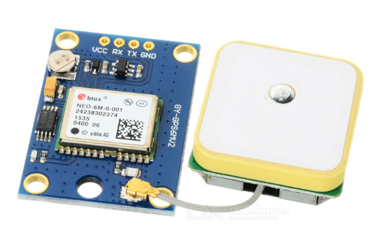

Figure 10 NEO-6M

**Chapter -4**

**Implementation**

**4.1 Implementation**

* We have used Arduino IDE to implement the project and used embedded c and c++.
* Used MQTT and REST protocols to connect to server and send data to IOT platform.

**4.2 Hardware configuration**

**4.3 Software required**

* Arduino IDE
* ThingerBoard

**4.3.1 Arduino IDE********(code image)**

Arduino IDE is an open source software that is mainly used for writing and compiling the code into the Arduino Module. It is an official Arduino software, making code compilation too easy that even a common person with no prior technical knowledge can get their feet wet with the learning process. It is easily available for operating systems like MAC, Windows, Linux and runs on the Java Platform that comes with inbuilt functions and commands that play a vital role for debugging, editing and compiling the code in the environment. A range of Arduino modules available including Arduino Uno, Arduino Mega, Arduino Leonardo, Arduino Micro and many more. Each of them contains a microcontroller on the board that is actually programmed and accepts the information in the form of code. The main code, also known as a sketch, created on the IDE platform will ultimately generate a Hex File which is then transferred and uploaded in the controller on the board.The IDE environment mainly contains two basic parts: Editor and Compiler where former is used for writing the required code and later is used for compiling and uploading the code into the given Arduino Module.This environment supports both C and C++,languages.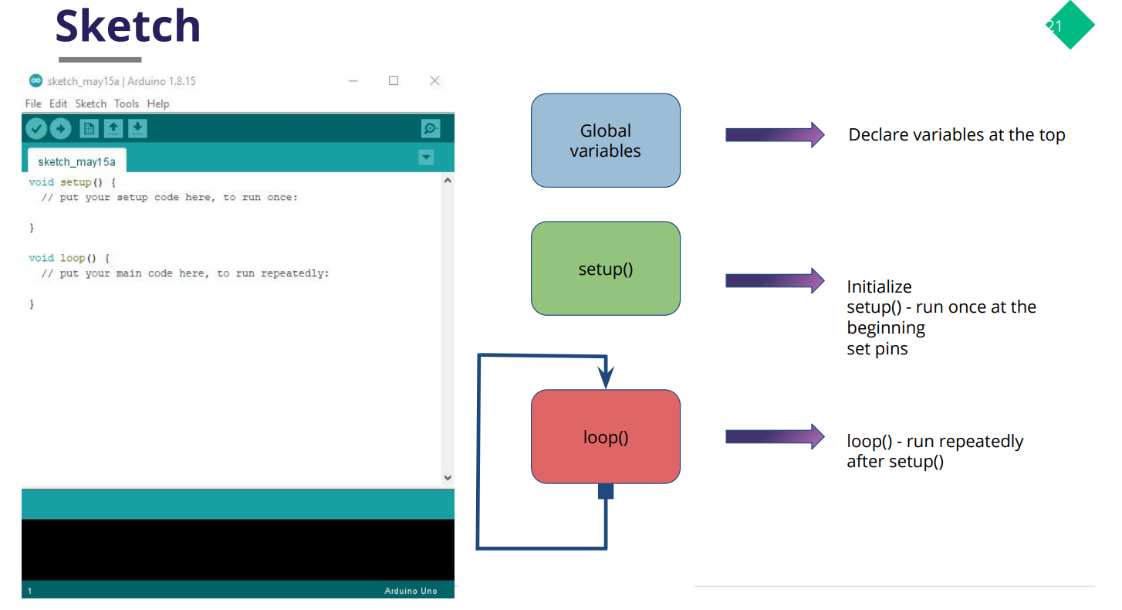

Figure 11 Arduino IDE

**4.3.2 ThingerBoard******(created platform image)**

ThingsBoard is an open-source IoT platform that enables rapid development, management, and scaling of IoT projects. Our goal is to provide the out-of-the-box IoT cloud or on-premises solution that will enable server-side infrastructure for your IoT applications.

With ThingsBoard, we are able to:

* Provision devices, assets and customers, and define relations between them.
* Collect and visualize data from devices and assets.
* Analyze incoming telemetry and trigger alarms with complex event processing.
* Control your devices using remote procedure calls (RPC).
* Build work-flows based on a device life-cycle event, REST API event, RPC request, etc.
* Design dynamic and responsive dashboards and present device or asset telemetry and insights to your customers.
* Enable use-case specific features using customizable rule chains.
* Push device data to other systems.
* Much more…

**Chapter -5**

**Results**

**5.1 Results*******image of output**

The prototype model was successfully implemented and tested. The ESP32 microcontroller was programmed to read sensor data and detect an accident. The system was also able to send an alert to emergency services with the location of the accident using Wi-Fi and GPS modules. The system's sensors was triggered when an accident was detected, and GPS co-ordinates are sent to the emergency services or related person. The system was able to operate autonomously and did not require any intervention from the vehicle's occupants. The system's response time was evaluated, and it was found to be significantly faster than traditional methods of reporting accidents. This is due to the system's ability to automatically detect accidents and send alerts to emergency services immediately. In terms of the discussion, the Automatic Vehicle Accident Detection and Rescue System using ESP32 has several advantages over traditional methods of reporting accidents. Firstly, the system can operate autonomously, which means that it can detect and report accidents without requiring any intervention from the vehicle's occupants. This is especially useful in situations where the occupants are unable to call for help themselves. Secondly, the system's response time is significantly faster than traditional methods of reporting accidents. This is because the system can detect accidents immediately and send alerts to emergency services with the location of the accident.

**Chapter-6**

**Conclusion**

**6.1 Conclusion**

The proposed system is developed to provide information about the accident occurs and the location of the accident. It helps to easily provide the assistant and help to the victim of the accident. This system uses the GPS module to locate the vehicle. MPU 6050, sensor is used to determine whether an accident had occurred, if an accident occurs the GPS and GSM modules installed in the system sends the information to the related person or emergency services. The systems we developed here is a kind of both hardware and software-based technology. A rescue measures in time with sufficient preparation at the correct place can save many lives. Thus, the proposed system can serve the humanity by a great deal as human life is valuable.

**6.2 Future enhancement**

* By increasing the technology we can also avoid accidents by providing alerts systems that can stop the vehicle to overcome the accidents.
* As ultra sonic sensor could be used for detection of objects but lacks in term of range ,therefore by using sensors having great coverage to detect the presence of object, so that user could get informed prior specially in fog, nights where vision gets blurred.

**Chapter -7**

**References**

**7.1 References**

[1] https://ncrb.gov.in/sites/default/files/ADSI-2021/adsi2021_Chapter-1A-Traffic-Accidents.pdf

[2] https://www.ibef.org/uploads/industry/Infrographics/large/automobile-infographic-may-2023.pdf

[3] https://morth.nic.in/sites/default/files/RA_2021_Compressed.pdf